Test Plan
Test | Description | Actual test call/data | Expected Output | Passed
1 | Load multiple files into BST | Load multiple CSVs | All records loaded successfully | Pass
2 | BST stores data grouped by year | Inspect store after load | Records grouped under correct year nodes | Pass
3 | Duplicate record prevention | Insert same record twice | Only one record stored | Pass
4 | Option 1 valid calculation | Month=3, Year=2016 | Correct avg + stdev wind speed | Pass
5 | Option 1 no data case | Month=4, Year=2016 | "April 2016: No Data" | Pass
6 | Month validation | Input: 13 | "Invalid input (1–12)" | Pass
7 | Year edge case (0) | Input: Year=0 | "No Data" | Pass
8 | Option 2 valid year | Year=2016 | Monthly averages displayed correctly | Pass
9 | Option 2 no data year | Year=2000 | All months show "No Data" | Pass
10 | Option 3 sPCC calculation | Month = 3 | Displays S_T, S_R, T_R values | Pass
11 | Option 3 no data case | Month = 4 | "April: No Data" | Pass
12 | Export function works | Option 4 | WindTempSolar.csv created | Pass
13 | Export file format check | Open CSV | Correct headers and values | Pass
14 | Program stability | Run multiple operations | No crash / consistent results | Pass
15 | Exit option | Input: 5 | Program exits cleanly | Pass

Test 1:
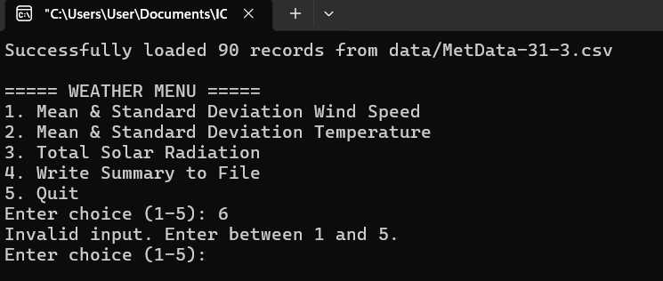

Test 2:
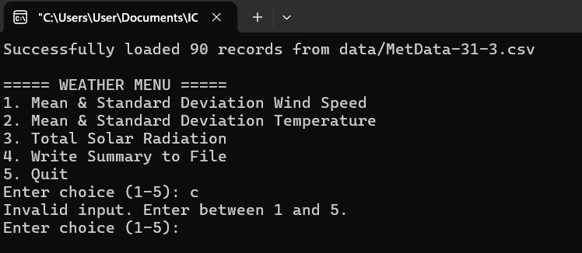

Test 3:
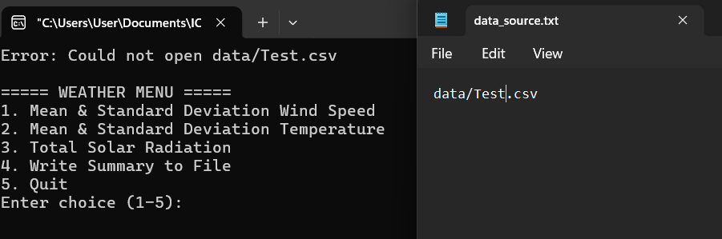

Test 4:
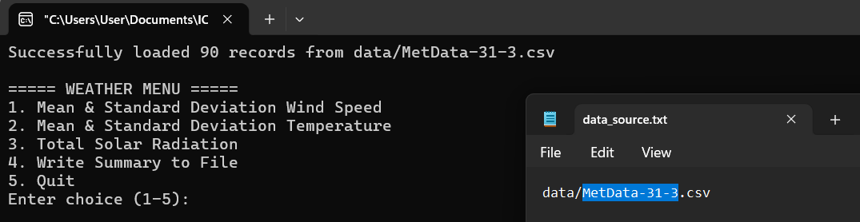

Test 5:
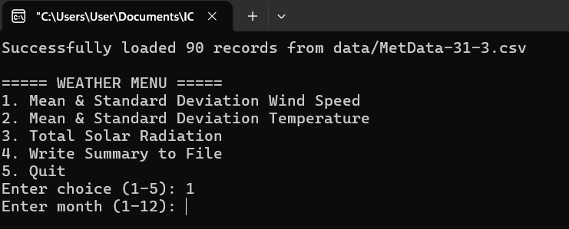

Test 6:
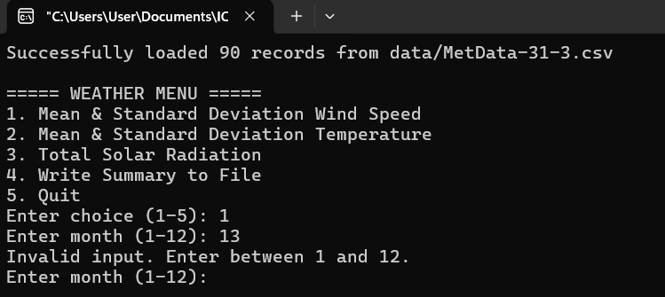

Test 7:
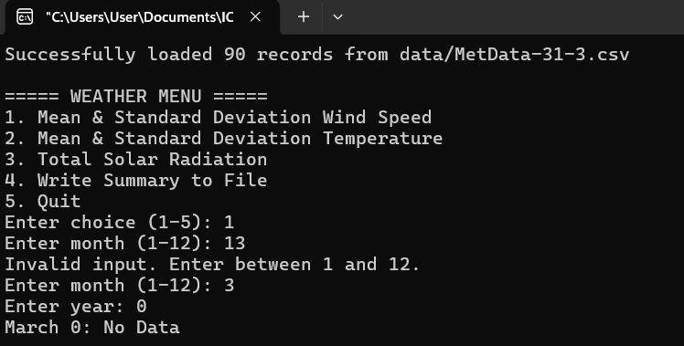

Test 8:
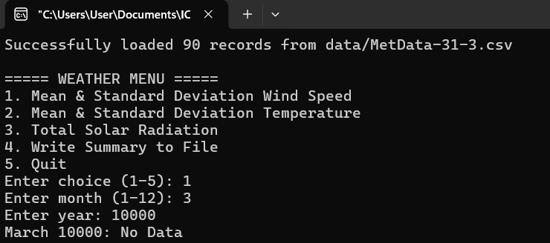

Test 9:
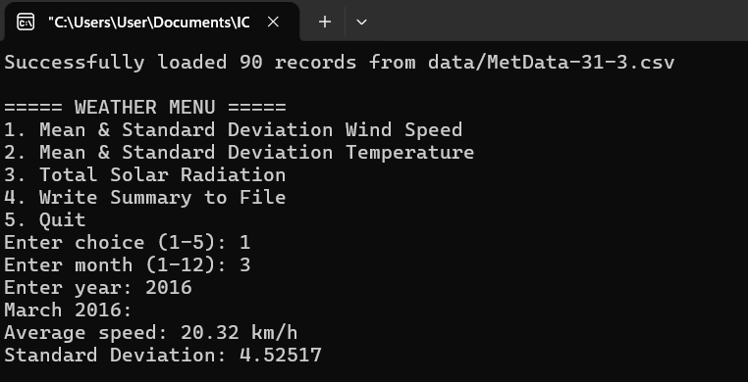

Test 10:
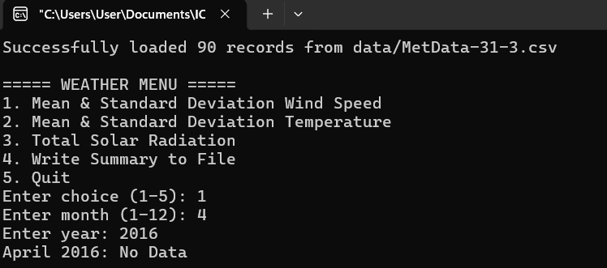

Test 11:
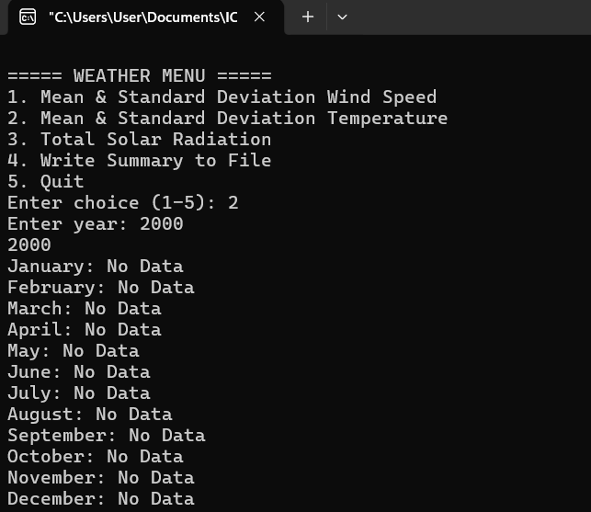

Test 12:
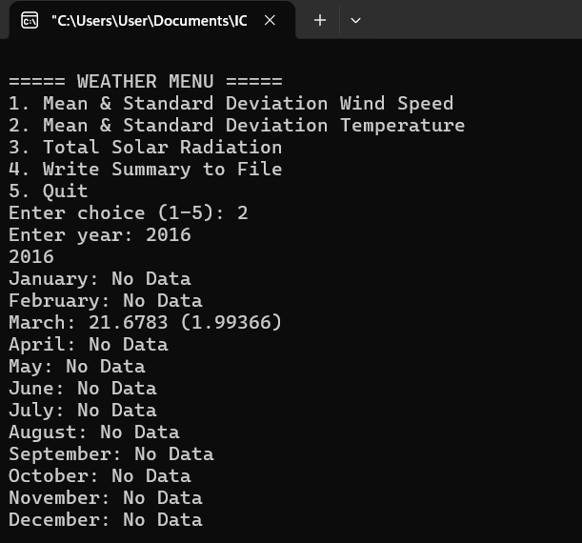
Test 13:
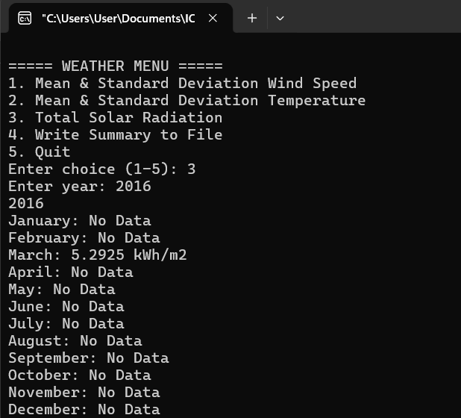
Test 14:
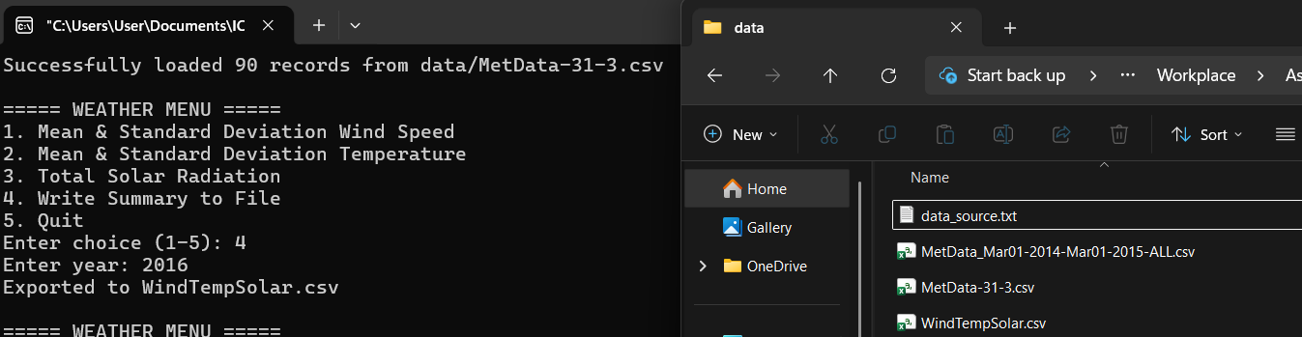
Test 15:
